Lab 6: Network Layer

# What you will do:

* Learn about the network layer
* Learn about the IP header.
* Learn how ARP works.
* Use Wireshark to receive constructed IP Packets
* Use a router to forward packets between two networks

# Things that you will need to know or learn:

* How to use xcap packet builder
* How to configure IP addresses and subnet masks, both statically and dynamically, using both the command line and the GUI, under Windows 7(see References below)
* How to copy text from the command line window (aka DOS box)
* How to enable and disable the Windows Firewall
* How to use Wireshark to see actual network traffic
* How to reset a Linksys E2500 router.
* How to upload a configuration file to a router running Tomato firmware

# What you need to submit and when:

* Complete the Pre-lab quiz on Blackboard before 8am on the day of your lab
* Complete the in-lab part of the exercise (see below) before the end of your lab period.
* Complete the Post-lab exercise on Blackboard before end of day, October 15, 2014.

# Required Equipment:

* Network cables available in lab
* A Linksys E2500 router running Tomato firmware (supplied in lab)

# Marks:

* Each of the three lab parts identified above are weighted equally, even though they may have a different number of points assigned to them.
* 20% of your final mark is for labs done during the course of the semester.

# References and Resources:

* Packet Tracer (for help on correct cabling; view of packets similar to Wireshark)
* How IP in Windows 7 (on Blackboard, Labs -> Lab 03)
* How to Wireshark (on Blackboard, Labs -> Lab 03)
* How to Cable (on Blackboard, Labs -> Lab 03)
* How to Build a packet in xcap (on Blackboard, Labs-> Lab 04)

# Task 0 – Overview and setup instructions

1. You will work is groups of 2 or 3 for this lab.
2. You and your partner(s) will need to use a Linksys E2500 router to connect your PCs together.
3. In Task 1 you will case and APR Request to be generate and observe the ARP Reply
4. In Task 2 you will create and send an IP packet to your partners and observe the response
5. In Task 3 you will configure a router and create a network with two separate segments and in Task 4 you will craft a packet and send it to your partners.

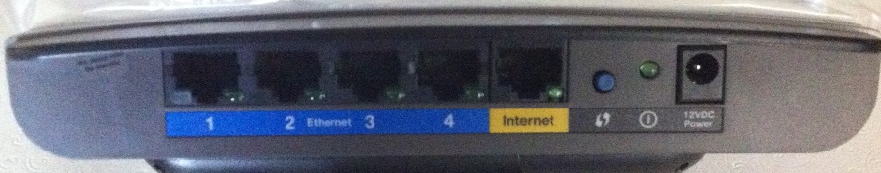

# Task 1 – Build the network and test reachability

1. **Disable your wireless NIC (don’t’ just turn it off, disable it) and turn your firewall(s) off**
2. Working with a partner, connect your PCs to the Linksys router. For this task we are only using the router as a switch so connect PC1 to Ethernet port 1, PC2 to Ethernet port 2 and if required PC3 to Ethernet port3, using the correct type of cable.

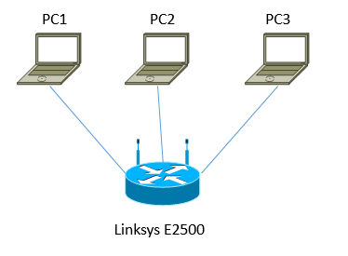

1. Configure your PC's IP address (for your Ethernet interface) as follows.
   1. PC 1
      1. IP address :192.168.3.1
      2. Subnet mask: 255.255.255.0
      3. Default gateway: Leave blank for now
   2. PC 2
      1. IP address :192.168.3.2
      2. Subnet mask: 255.255.255.0
      3. Default gateway: Leave blank for now
   3. PC 3 (if needed)
      1. IP address :192.168.3.3
      2. Subnet mask: 255.255.255.0
      3. Default gateway: Leave blank for now

From a Windows command prompt, type in ***ipconfig*** to verify IP address on Ethernet interface corresponds to the address above.

1. You will now capture an ARP request and an ARP reply. On each PC open a cmd prompt (make sure you open it as “Administrator”).
   1. Start a Wireshark capture, then in the command prompt type the following 3 commands, one per line
      1. arp –d
      2. Ping 192.168.3.X (where X is one of your partners IP)
      3. arp –a
   2. Stop the capture and **save** it as **Lab6-Task1.pcap**

## Checkpoint 1: Show the Wireshark capture to the instructor, filter to show only ARP messages

# Task 2 – Craft an IP packet using xcap

1. Launch xcap Packet Builder. Select your Ethernet Interface and start it (see Lab 04)
2. Create a new packet group, call it Lab 06
3. You are now going to craft and send an IP packet to each of your partners.
4. Create a new packet, call it Task2.1, double click on the packet and complete the packet as follows:
   1. Ethernet
      1. Destination MAC: *your partners MAC*
      2. Source MAC: *your MAC address*
      3. Type: Select 0x0800 (IPv4) from the drop down list
      4. Leave “Append FCS at the end of packet” unchecked
      5. Click Next
   2. IPv4
      1. Version: *should be 4* why?
      2. Header Length: *leave “Auto calculate” checked*
      3. Total Length: *leave “Auto calculate” checked*
      4. Leave everything up to Source Address at the default values
      5. Source Address: *Set your IP address*
      6. Destination Address: *Set to your partner’s IP*
      7. Protocol: Check custom and set the value to 0xFD – why 0xFD?
      8. Leave everything else at the defaults
      9. Click next
   3. Data
      1. Open “Notepad” and type a short message to your partner. Something like Hi John, How are you? from Susan.
      2. Count the number of characters in your message (including spaces).
      3. In the “Length” box enter your character count
      4. Copy you message from Notepad.
      5. Select all the “00”s in the data area and use CTRL-V to paste in your message. The “00”s should change to the hexadecimal numbers representing the message you typed. The right hand portion of the window should contain the ASCII text you want to send.
      6. Save your packet and then click “Close”
5. When everyone is ready, on each computer start a Wireshark capture. Send your packets and stop and save the wireshark capture (**Lab6-Task2.pcap**). Everyone needs to send and receive at least one packet.

## Checkpoint 2: Show the crafted packet and the Wireshark capture to the instructor. Make sure you look for replies from your partner(s) and be ready to explain the replies.

# Task 3 – Change Network Topology and Configure the Linksys Router

1. Unplug PC1 from the router's Ethernet port, and plug it into it's Internet port.

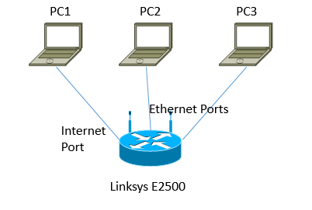

1. Configure your PC's IP address as follows   
    (THIS STEP MUST BE DONE BEFORE STEP 3).
   1. PC 1
      1. IP address :192.168.2.1
      2. Subnet mask: 255.255.255.0
      3. Default gateway: 192.168.2.254
   2. PC 2
      1. IP address :192.168.1.2
      2. Subnet mask: 255.255.255.0
      3. Default gateway: 192.168.1.254
   3. PC 3
      1. IP address :192.168.1.3
      2. Subnet mask: 255.255.255.0
      3. Default gateway: 192.168.1.254
2. Reboot all computers and perform a 30/30/30 reset on the router.   
   **Note: The reset button on these routers is on the bottom of the router, not the button on the back. Please press *gently* to hear/feel it click, it's so tiny inside!**
3. When the PCs have rebooted, type in ***ipconfig*** from a windows command prompt to verify the IP address on Ethernet interface corresponds to the address above.
4. Wait for the router to reboot then using PC2 or PC3 open a web browser and connect to <http://192.168.1.1>. Login with the username ***admin*** and ***password*** admin. You should see a screen like the one below

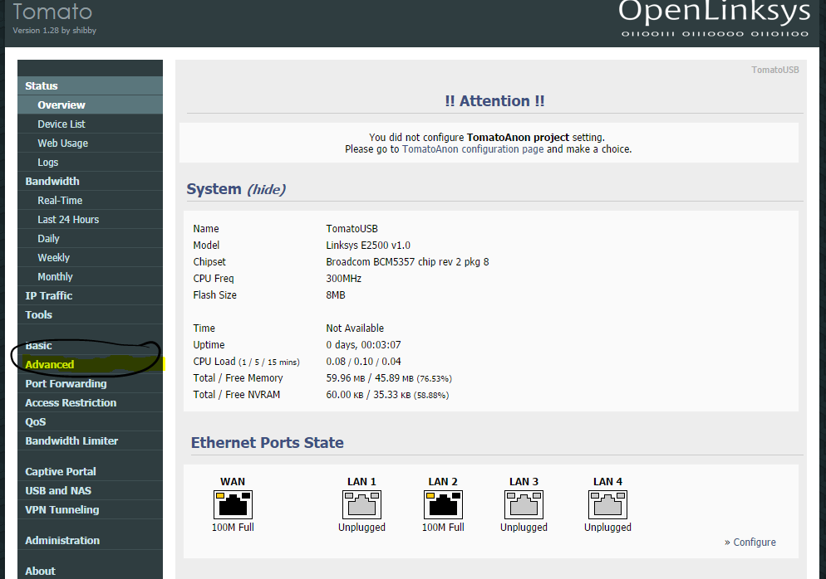

1. Click on the “Advanced” menu item, then "Routing" item.   
    On the following spingcreen you should see the screen shown below.   
   Change the “mode” to “router” and uncheck “DHCP Routes”
2. When this is done scroll to the bottom-right of the page and click “Save”. You should see the following message

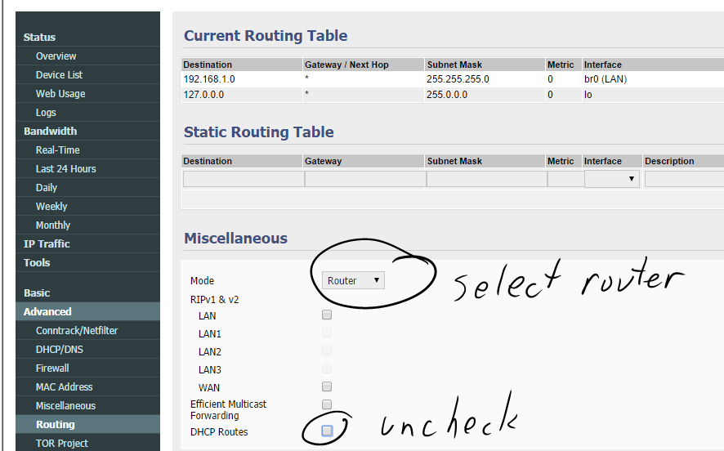

1. Now on the left hand menu, click “Basic”

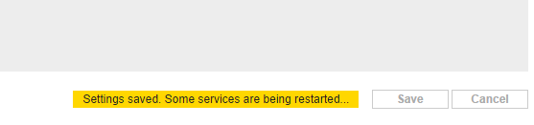

1. In the WAN/Internet section change “Type” to Static, “IP Address” to 192.168.2.254 and the “Subnet Mask” to 255.255.255.0, leave everything else in this section at the defaults

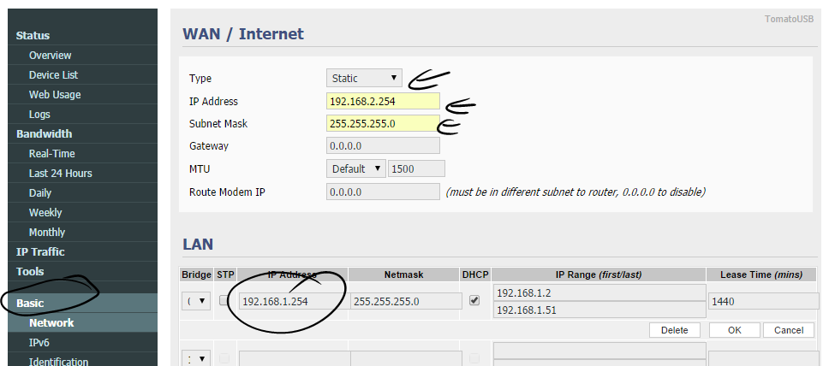

1. In the LAN section change the “IP Address” to 192.168.1.254, then [ OK ] at right immediately below the LAN section.  
    Leave everything else unchanged.
2. Scroll to the bottom of the page and click “Save”. The router should now reboot.
3. Await the reboot (15 -> 30 sec), then [continue] and log in again (admin & admin).
4. Confirm your setting changes, scroll down verifying WAN and LAN addresses
5. Navigate and select: Advanced >> Firewall >> Respond_to_ICMP [**v**] >> Save
6. Await the save completion. Now open a command prompt on each PC and   
   **ping** your **Default Gateway**. When the ping completes successfully (and only if it’s successful) look at your PC’s ARP table and get the MAC address of the router.

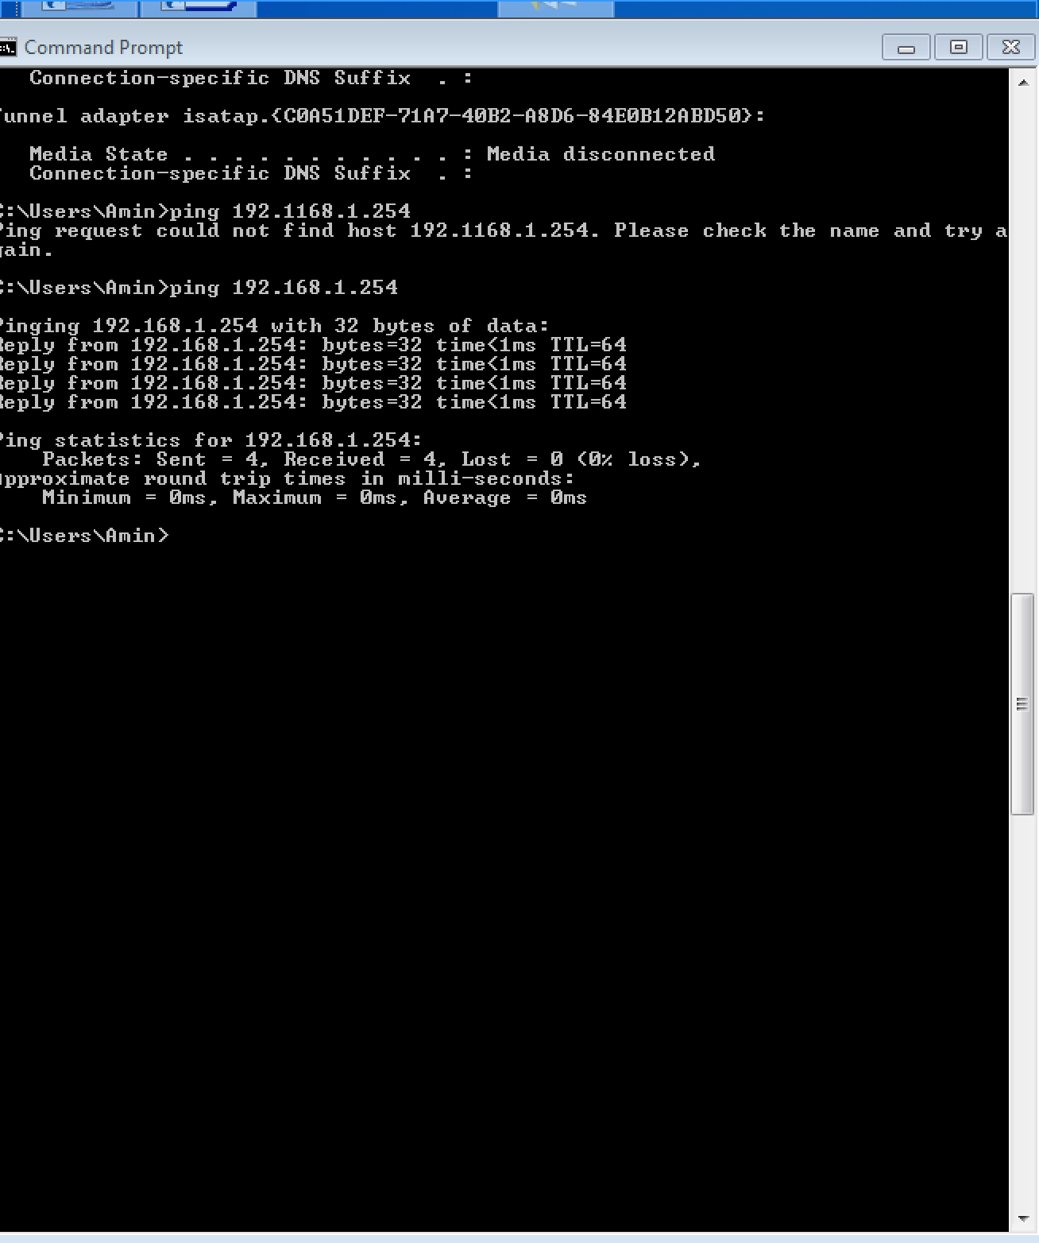

1. . PC1 should see a different MAC than PC2 or PC3; why? Because it is not in the same network side

# Task 4 – Send crafted IP packet to your partner on the other side of the router.

1. In xcap make a copy one of the packets you created in Task 2 that you sent to your partner (the one that is on the other side of the router). Rename this packet Task 4.1 and is necessary Task 4.2
2. Modify the packet so you can now send it to a PC on the other side of the router.
   1. PC1 sends a packet to PC2 and PC3 (if it exists)
   2. PC2 sends a packet to PC1
   3. PC3 sends a packet to PC1
3. When everyone is ready, start a Wireshark capture and then send your packets. Send them a few times to be sure you captured them.   
   Stop and **save** your capture (**Lab06Task4.pcap**).

Mac address stay it is only upper level stuff that goes across

Network layer will not care about mac address only ip address

## Checkpoint 3: Show the crafted packet and the capture to your instructor.

# Task 5 - Challenge

1. Try sending broadcast Ethernet frames like you did in Lab and see if your partner (on the side of the router) can see them
2. Notice that broadcasts don’t pass through the router.
3. No check point for this task. Just think of why this is so.
4. Think what would happen if you changed the MAC address of the Task 3 frame to a broadcast MAC. Would your partner still receive it? If time permits try it, the answer might surprise you.

# Task 6 Cleanup

1. Make sure you have saved all the results you got during this lab period. Always share your results with your lab partner.
2. Turn your firewall back on, re-enable your wireless NIC and set your Ethernet NIC to “Obtain and IP address automatically”
3. Reboot your computer.
4. Make sure that the network wiring for your station (and your partner's station) is back to its default configuration
5. Return the router to the location specified by your instructor
6. Be sure to complete the post-lab questions before end of day October 15, 2014 on the day of your next lab period

Blue port on router is one side and the yellow is another network

Pc 1 wants to send a packet to pc on other side it has to send it first to router with mac address of router and ip of destination

We first send a packet to router and router figure it out where to send it